**1.Introduction**

* **GITHUB**

**2.Steps**

* **CREATING GIT ACCOUNT**
* **DOWNLOADING GIT BASH AND INSTALLATION**
* **GENERATING SSH KEY IN GITBASH**
* **ADD SSH KEY TO THE GIT ACCOUNT**
* **COLLABORATING USER IN GI**T

# 1.Introduction

Git is a [free and open source](https://git-scm.com/about/free-and-open-source) distributed version control system designed to handle everything from small to very large projects with speed and efficiency.

GitHub is a code hosting platform for collaboration and version control.

GitHub lets you (and others) work together on projects.

GitHub essentials are:

* Repositories
* Branches
* Commits
* Pull Requests
* Git (the version control software GitHub is built on)

### Example

$ git push origin heroku

$ cd /etc/

$ ls

## Rep**ository**

A GitHub repository can be used to store a development project.

It can contain folders and any type of files (HTML, CSS, JavaScript, Documents, Data, Images).

A GitHub repository should also include a licence file and a README file about the project.

A GitHub repository can also be used to store ideas, or any resources that you want to share.

## **Branch**

A GitHub branch is used to work with different versions of a repository at the same time.

By default a repository has a master branch (a production branch).

Any other branch is a copy of the master branch (as it was at a point in time).

New Branches are for bug fixes and feature work separate from the master branch. When changes are ready, they can be merged into the master branch. If you make changes to the master branch while working on a new branch, these updates can be pulled in.

## **Commits**

At GitHub, changes are called commits.

Each commit (change) has a description explaining why a change was made.

## **Pull Requests**

Pull Requests are the heart of GitHub collaboration.

With a pull request you are proposing that your changes should be merged (pulled in) with the master.

Pull requests show content differences, changes, additions, and subtractions in colors (green and red).

As soon as you have a commit, you can open a pull request and start a discussion, even before the code is finished.

A a great way to learn GitHub, before working on larger projects, is to open pull requests in your own repository and merge them yourself.

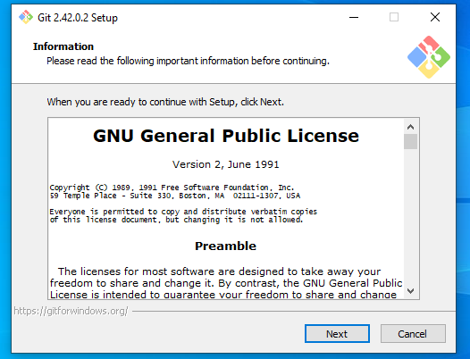

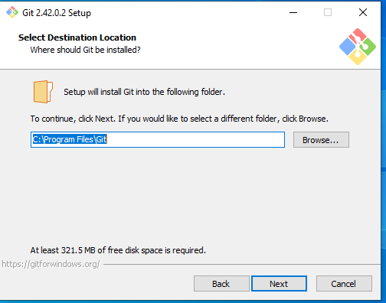

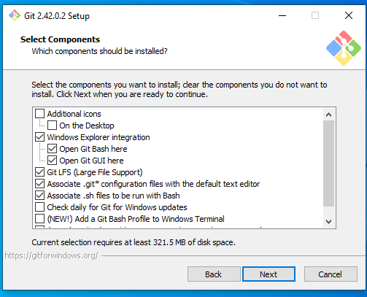

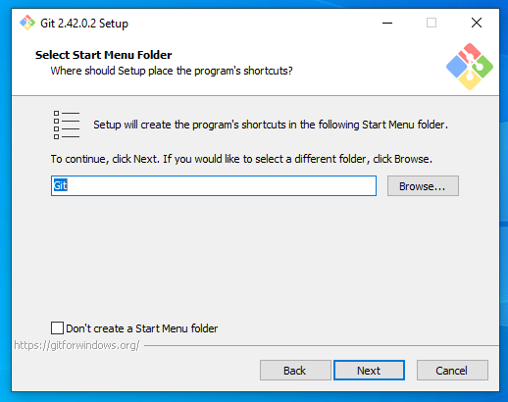

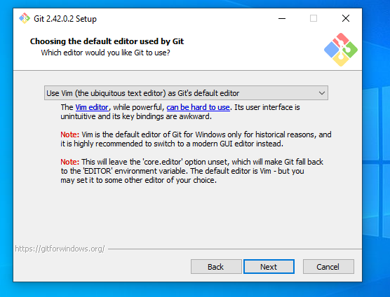

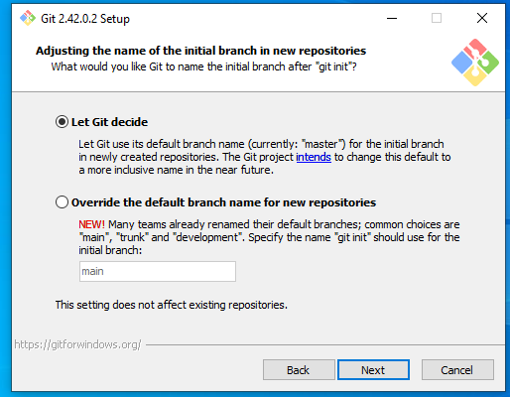

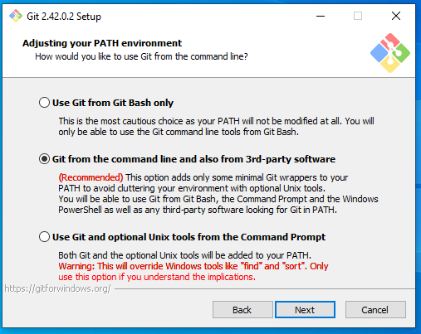

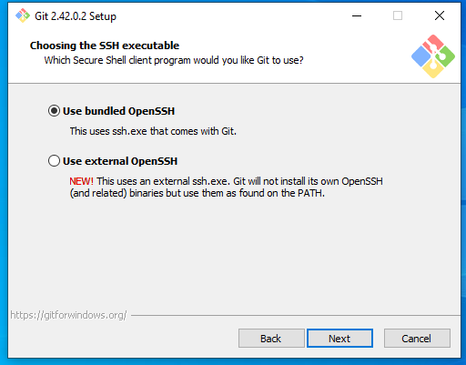

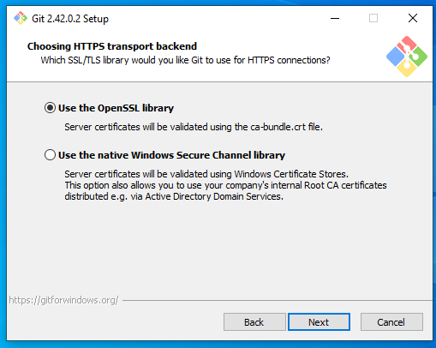

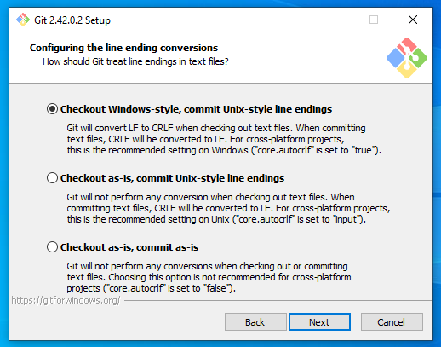

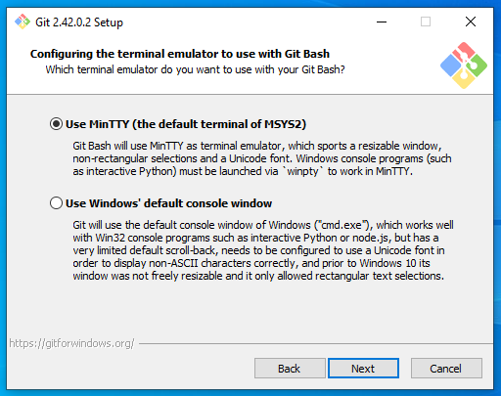

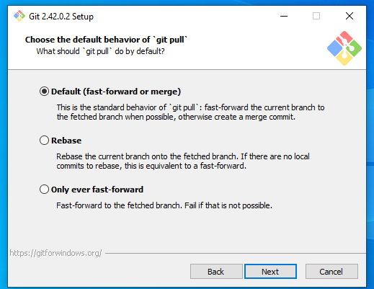 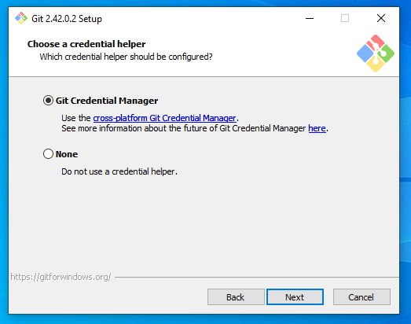

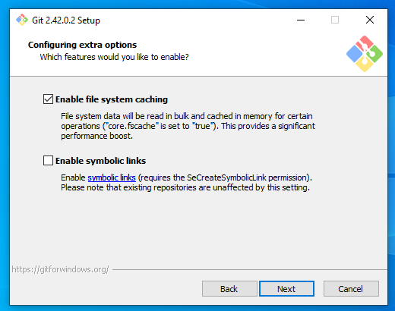

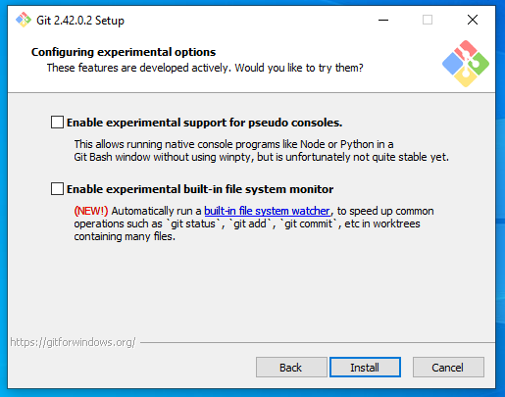

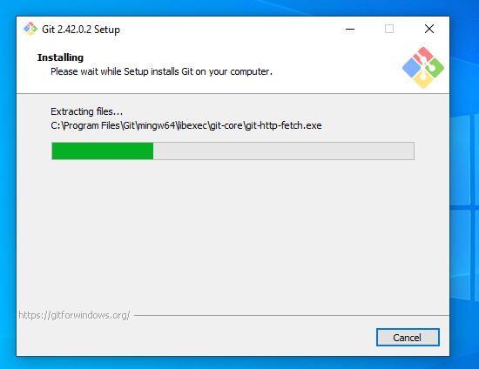 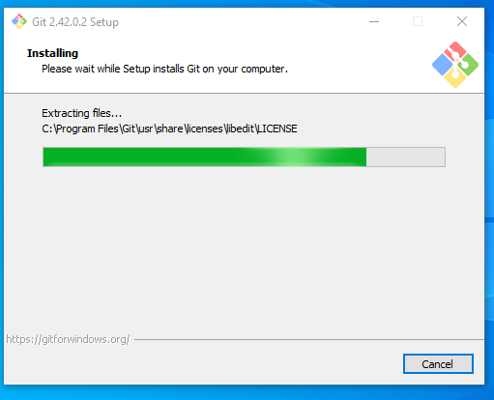

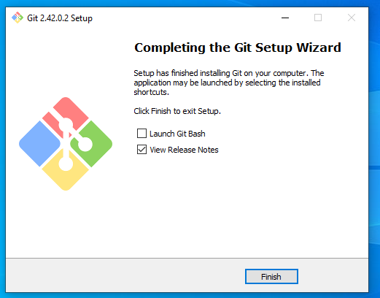

Login to Github account

User

Password

After login go to settings

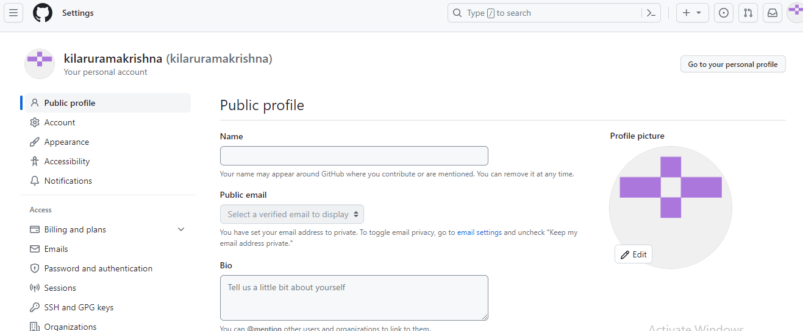

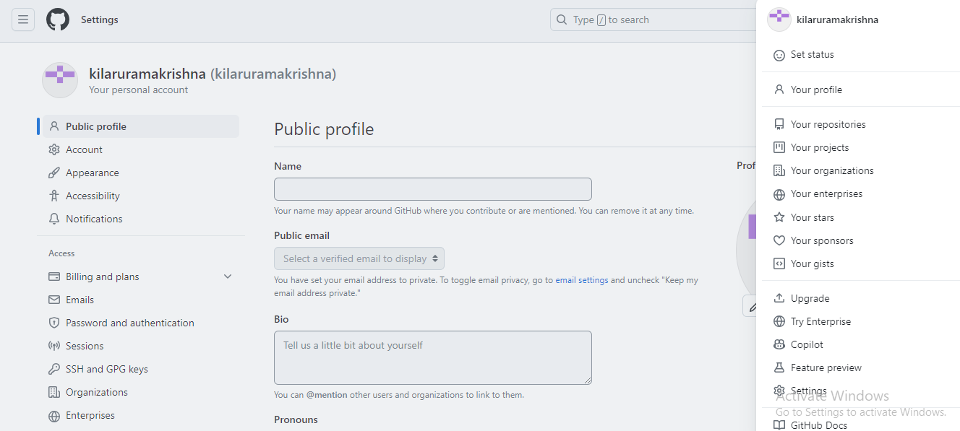

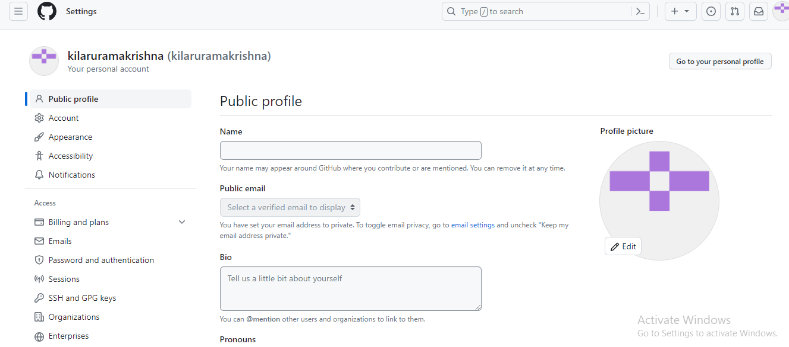

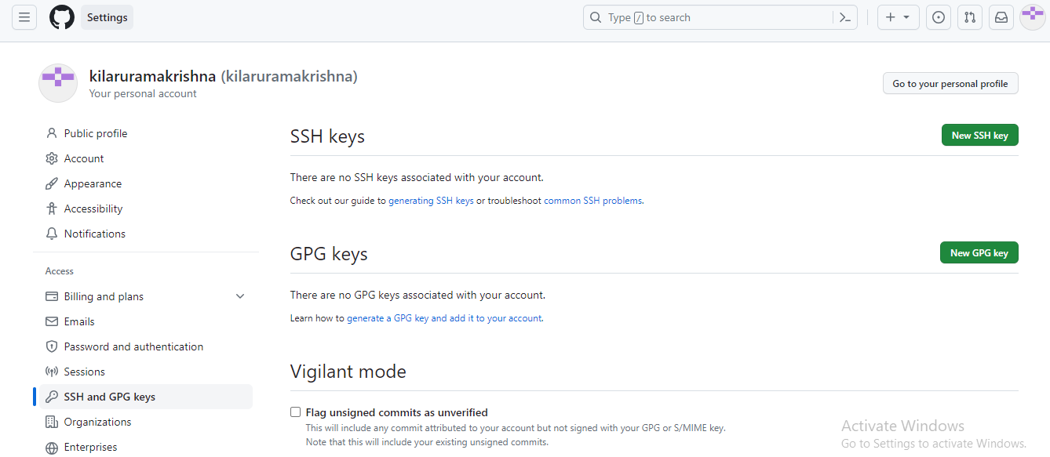

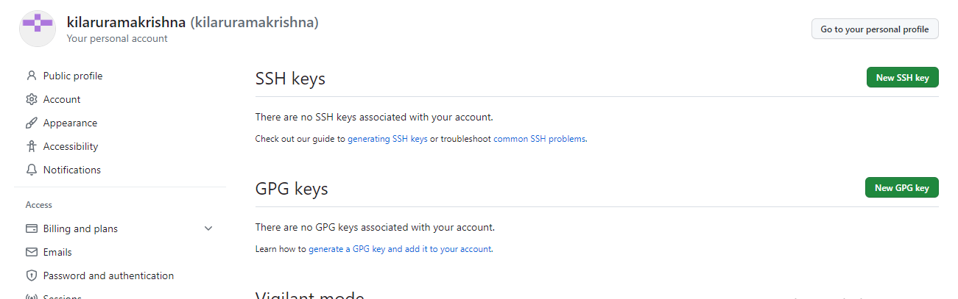

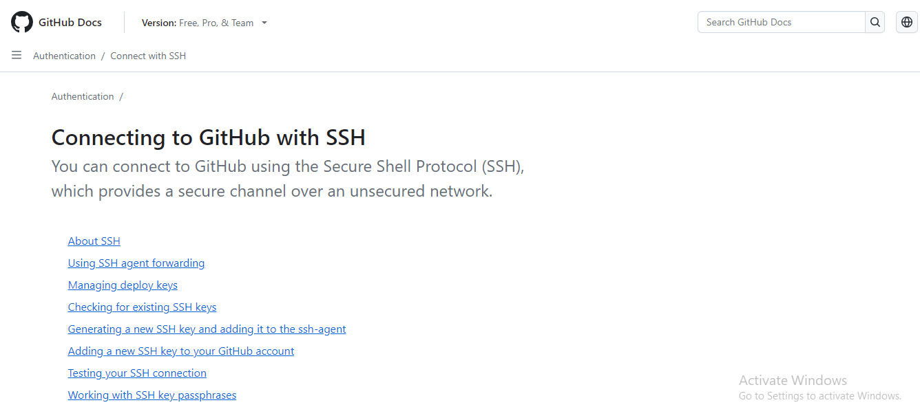

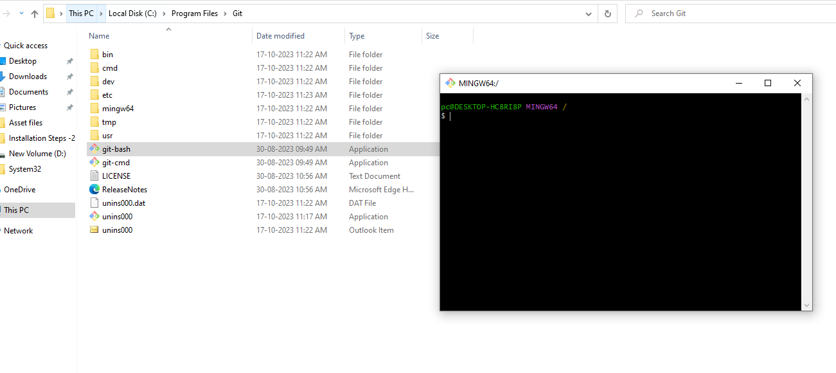

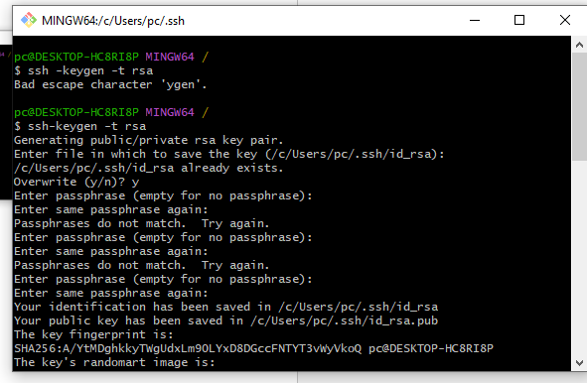

ssh -keygen -t rsa

pc@DESKTOP-HC8RI8P MINGW64 /

$ ssh-keygen -t rsa

Generating public/private rsa key pair.

Enter file in which to save the key (/c/Users/pc/.ssh/id_rsa):

/c/Users/pc/.ssh/id_rsa already exists.

Overwrite (y/n)? y

Enter passphrase (empty for no passphrase):

Enter same passphrase again:

Your identification has been saved in /c/Users/pc/.ssh/id_rsa

Your public key has been saved in /c/Users/pc/.ssh/id_rsa.pub

The key fingerprint is:

SHA256:A/YtMDghkkyTWgUdxLm90LYxD8DGccFNTYT3vWyVkoQ pc@DESKTOP-HC8RI8P

The key's randomart image is:

+---[RSA 3072]----+

|+++O*=o+.=o . |

|.+o.O+. o oE . |

|.. .o== . .... .|

|. ooB= . .o...|

| o BS . ..o |

| o .o + |

| . |

| |

| |

+----[SHA256]-----+

User name create

git config --global user.name "ramakrishna"

pc@DESKTOP-HC8RI8P MINGW64 /

$ cd ~/.ssh

pc@DESKTOP-HC8RI8P MINGW64 ~/.ssh

$ ls -ltr

total 7

-rw-r--r-- 1 pc 197121 113 Oct 17 11:49 id_ed25519.pub

-rw-r--r-- 1 pc 197121 484 Oct 17 11:49 id_ed25519

-rw-r--r-- 1 pc 197121 2655 Oct 17 12:07 id_rsa

-rw-r--r-- 1 pc 197121 572 Oct 17 12:07 id_rsa.pub

pc@DESKTOP-HC8RI8P MINGW64 ~/.ssh

$ cat id_rsa.pub

ssh-rsa  pc@DESKTOP-HC8RI8P

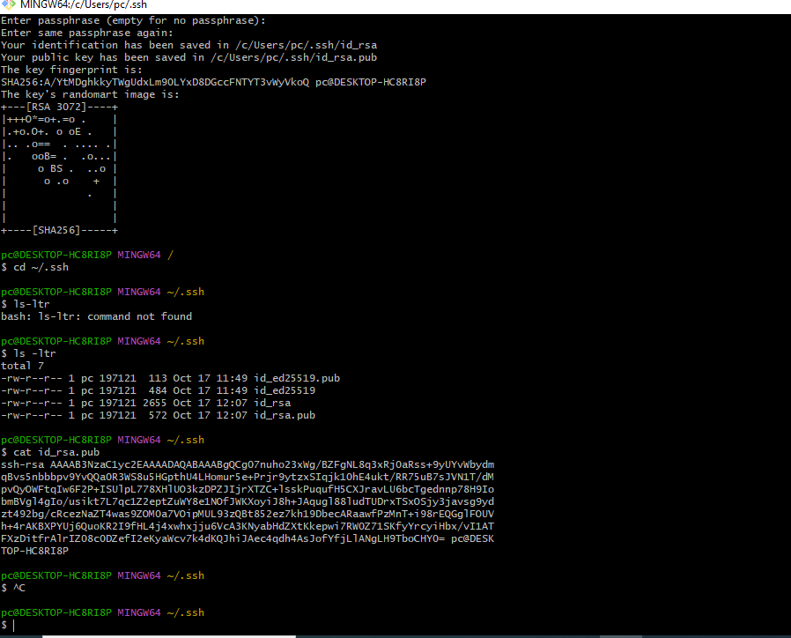

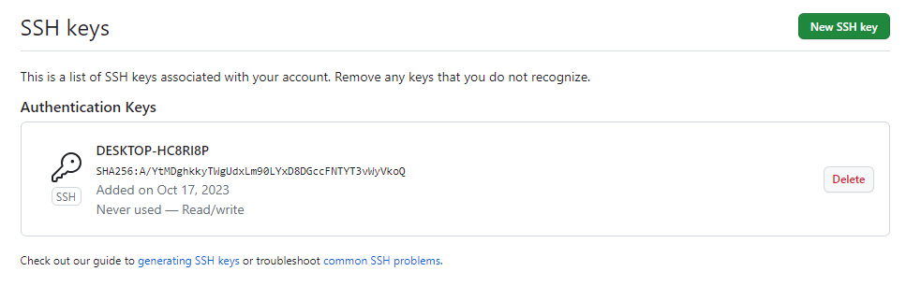

Git config - -global user.name “ramakrishna”

Enter

Git config –global user.email [ramakrishna.k@thresholdsoft.com](mailto:ramakrishna.k@thresholdsoft.com)

Enter

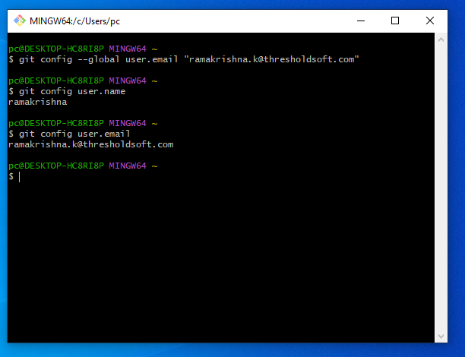

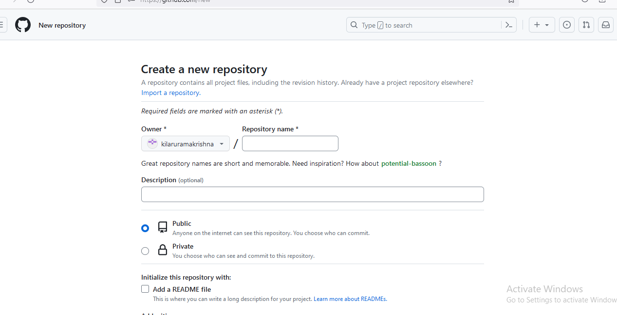

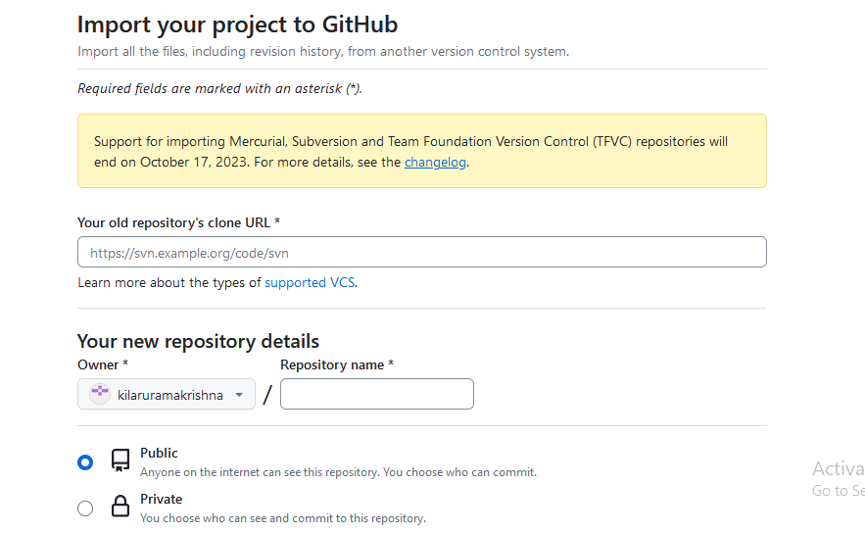

Andriod studio github token generation

